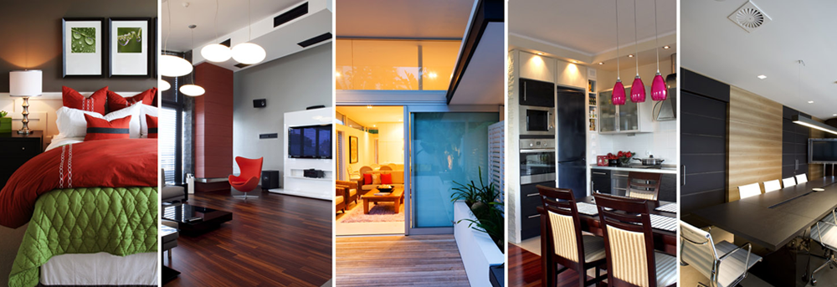
Uncovering Your
Inner Style

Look around you – your style clues are everywhere!
Which colors and styles do you like to wear?
What is in your keepsake box, your wallet/purse, or your closet that is special to you?
What colors make you feel happy, sad, energized?

What are your favorite stores to shop in?

True personal style reflects your life! What you like now is based on past experiences. What you'll like in your future is based on the look you're building now!
Be honest with yourself: What do you really love?

Start by gathering objects, colors and patterns that speak to you or elicit a strong response. As you gather objects, start placing them in your bin or digital place.
You will use these for a style board shown in a digital format; pinterest board, powerpoint or keynote. Other visual collection sites are also ok to use. As your ideas grow your board will develop. As you continue to work eliminate those items that you no longer feel strongly reflect you as you are today.
Study the mood of the objects you collected.
Are they romantic, playful, creative, classic, rich, simple, modern, eclectic?

Review the rubric to ensure that you have assembled and addressed each item as required. Think of the placement of your items on the board you select.
Lastly build your board to display a true sense of you!

Grading Rubric for Uncovering Your Inner Style
Poster board or appropriate board (5 pts)
At the minimum, include the following: (60 pts)
1 fabric sample
1 paint sample
1 example of a furniture piece
1 example of an entire room concept
1 sample from nature that inspires you
1 outside/random sample (3D)
1 interior item that you hand draw
Your favorite color
Picture that show your personal style
Your name
A word that describes your personal style
The board should be an overall description of you (font, shape, etc.)
1 separate item that relates to the work of an interior designer
1 separate item that relates to the work of an architect
Summaries: (20 pts.)
I feel that my style reflects ________________________ and is shown in this way:

Give one thought that I want others to 'get' as they view my board that may not be obvious.

Overall appearance of my style board and Presentation: (15 pts) Neat in appearance, used appealing professional layout. Presented in a way that it was easy to understand.

